Html tags:

<h1></h1>

      <h2></h2>

      <h3></h3>

      <h4></h4>

      <h5></h5>

      <h6></h6>

      <p></p>

      <div class="atribut_div" id="divan" ></div>

      <a href=""></a>

      <span></span>

      <input type="button" value="button" name="but">

      <input type="checkbox">

      <input type="color">

      <input type="date">

      <input type="datetime-local">

      <input type="email">

      <input type="file">

      <input type="hidden">

      <input type="image">

      <input type="month">

      <input type="number">

      <input type="password">

      <input type="radio">

      <input type="range">

      <input type="reset">

      <input type="search">

      <input type="submit">

      <input type="tel">

      <input type="text">

      <input type="time">

      <input type="url">

      <input type="week">

      <header></header>

      <nav></nav>

      <footer></footer>

      <br>

      <label for="name: "></label>

      <section></section>

      <textarea name="full" id="" cols="30" rows="10"></textarea>

      <button></button>

      <table></table>

      <td></td>

      <tr></tr>

      <col span="2" style="background-color:red">  
    <col style="background-color:yellow"> описание столбца в таблице

      <time datetime="YYYY">yuiu</time>

      <address></address>

      <audio src=""></audio>

      <video controls>

        <source src="" type="video/mp4">

        <source src="" type="audio/mpeg">

      </video>

      <code></code>

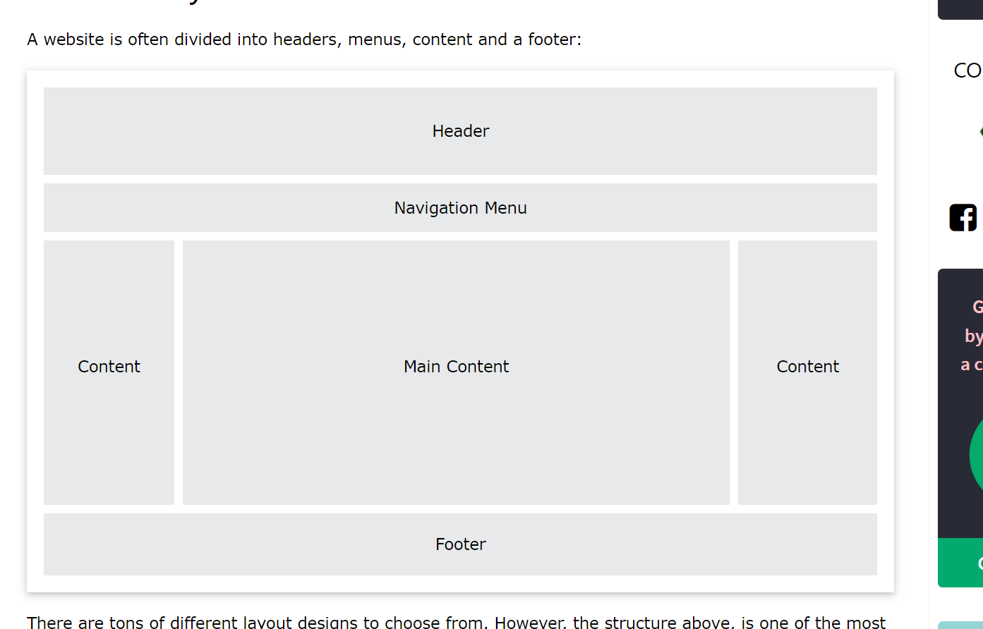

*{

    color: res, #0000, rgb(red, green, blue);

    border: #0000 1px, solid;

    background: black   d: url(img_navsprites.gif) 0;

    margin: 0 0 0 0;

    padding: 23px;

    text-align: center !important;

    height: 100 px, em, rem, %;

    width: 100;

    outline-style, outline-color, outline-width, outline-offset, outline

    position: relative; absolute; po

*/* text */*

    text-align

text-align-last

direction

unicode-bidi

vertical-align

text-decoration-line

text-decoration-color

text-decoration-style

text-decoration-thickness

text-decoration

ссылка

a:link - a normal, unvisited link

a:visited - a link the user has visited

a:hover - a link when the user mouses over it

a:active - a link the moment it is clicked

list-style-type circle, squre, upper-roman, lower-alpha

table

border-collapse: collapse;

display bloc, inline, inline-block, none,

visibility: hidden;

max-width, max-hieght, min-width, min-height

z-index: 0;

The overflow property specifies whether to clip the content or to add scrollbars when the content of an element is too big to fit in the specified area.

The overflow property has the following values:

visible - Default. The overflow is not clipped. The content renders outside the element's box

hidden - The overflow is clipped, and the rest of the content will be invisible

scroll - The overflow is clipped, and a scrollbar is added to see the rest of the content

auto - Similar to scroll, but it adds scrollbars only when necessary

::dropdown ::after ::before :hover. have atribut then a[target0][color; red]

@keyframes

animation-name

animation-duration

animation-delay

animation-iteration-count

animation-direction

animation-timing-function

animation-fill-mode

animation

box-reflect6

column-count

column-gap

column-rule-style

column-rule-width

column-rule-color

column-rule

column-span

column-width

}